Tifton/Tift County

FIS ID: 32542 -- TIFT CO - TIFTON OMEGA/ELDORADO RD PH III MSWL

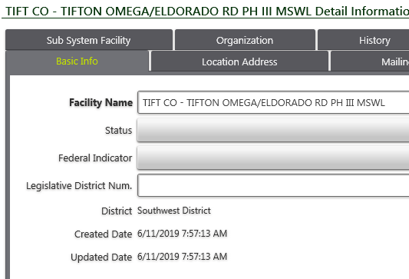

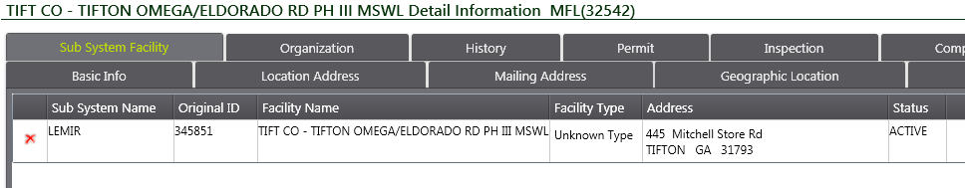

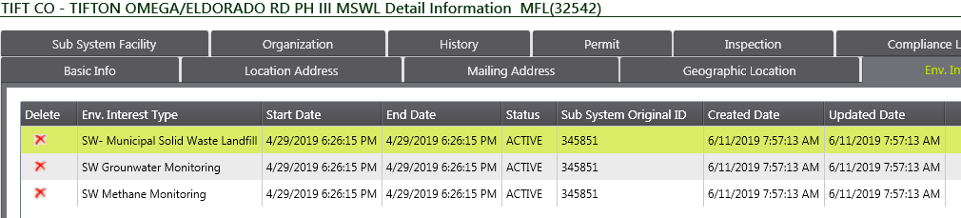

FIS ID: 33820 -- TIFTON - OMEGA/ELDORADO RD PH 1 (SL)

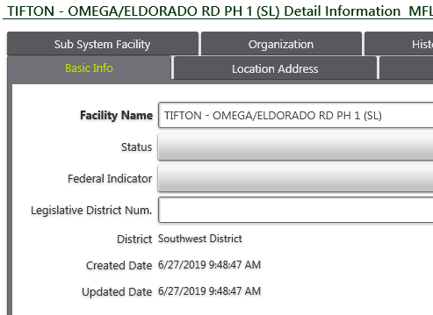

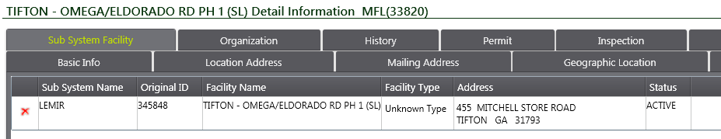

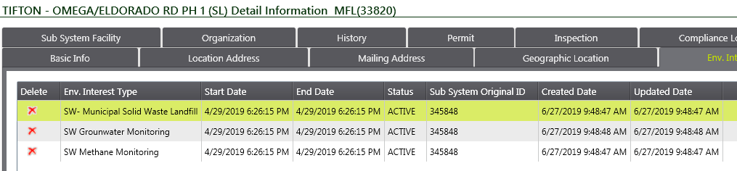

FIS ID: 34841 -- TIFTON TIFT COUNTY LANDFILL

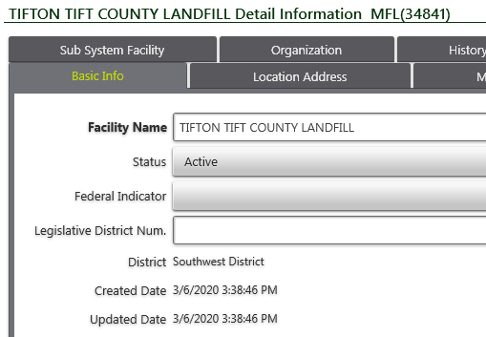

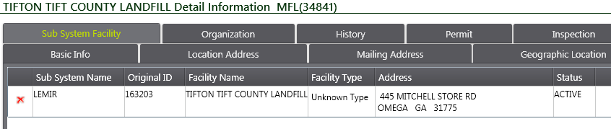

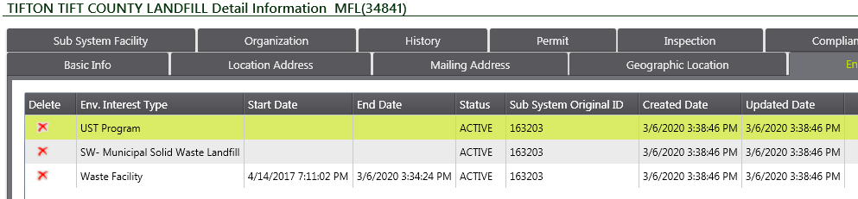

FIS ID: 8176 -- TIFTON/TIFT COUNTY LANDFILL

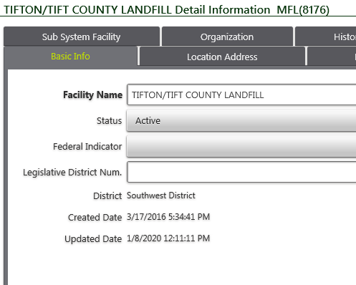

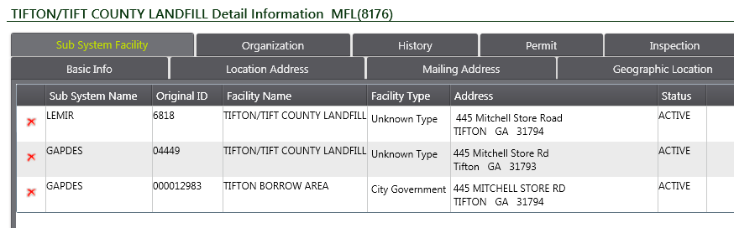

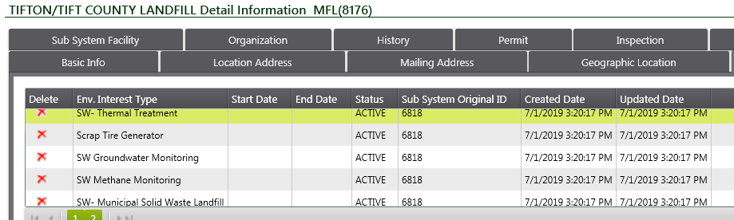

GEOS ID: 270475 -- Tifton - Omega/Eldorado Rd Ph 1 (SL)

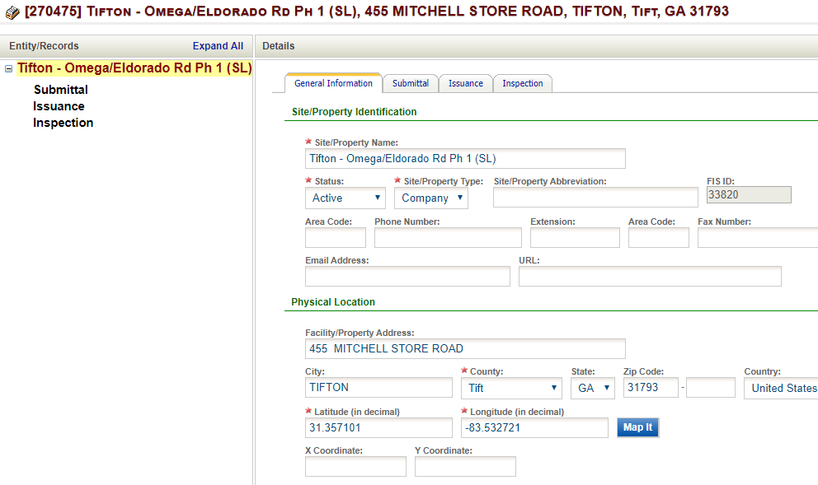

NO Submittals… No Permits – New Facility created by Mike

GEOS ID: 15519 -- TIFTON/TIFT COUNTY LANDFILL

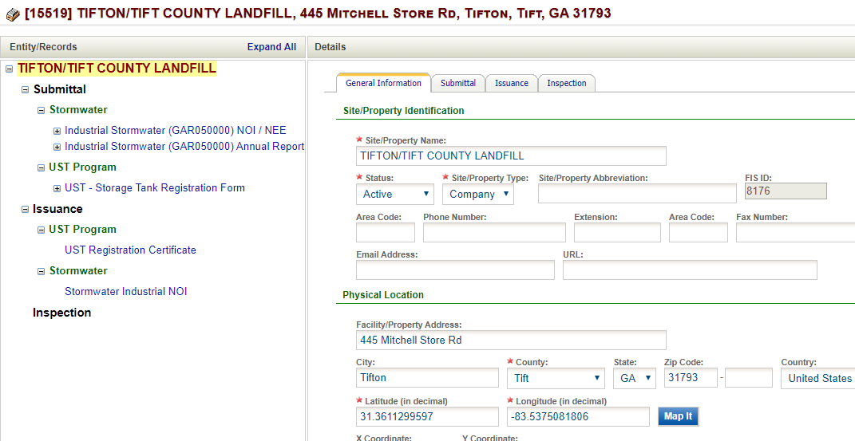

No Permits or submittals for SW

GEOS ID: 63157 -- TIFTON LANDFILL

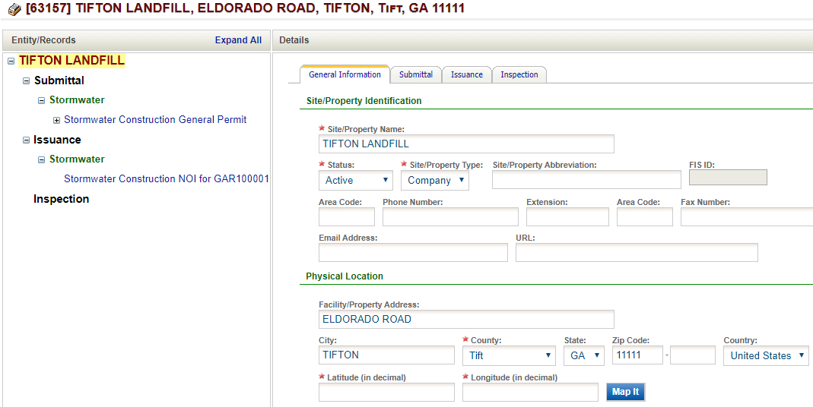

Permit and submittals for Construction Stormwater ONLY

LEMIR ID: 345848 -- Tifton - Omega/Eldorado Rd Ph 1 (SL)

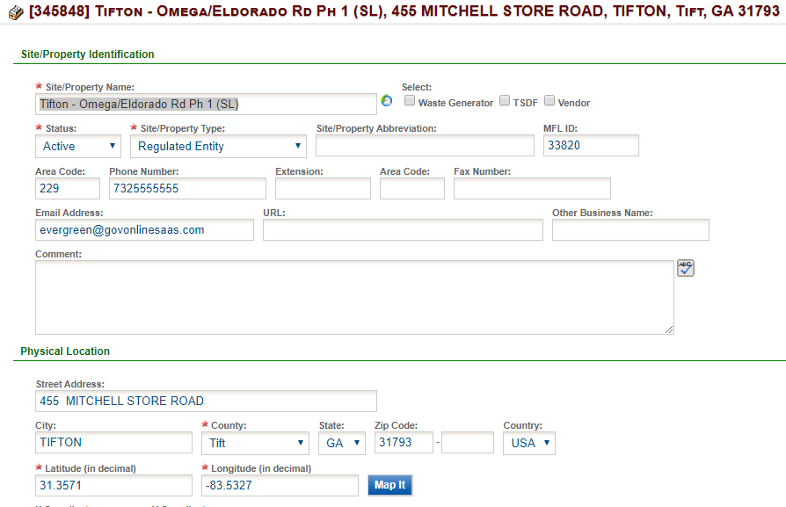

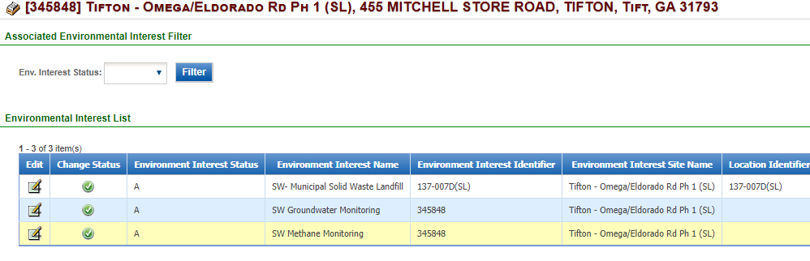

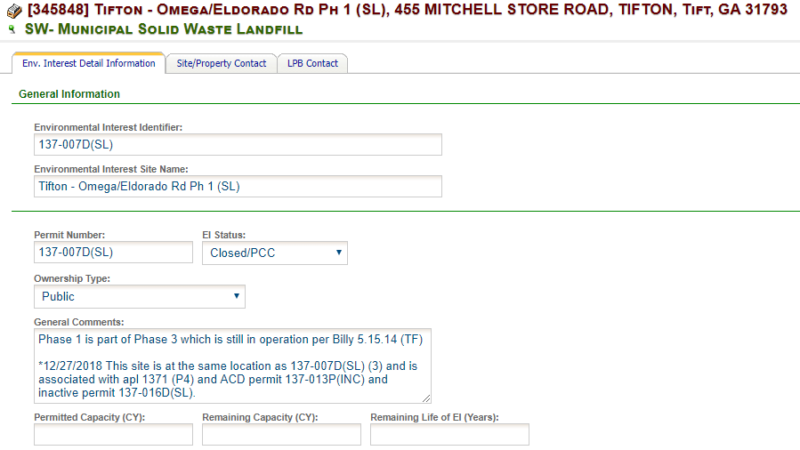

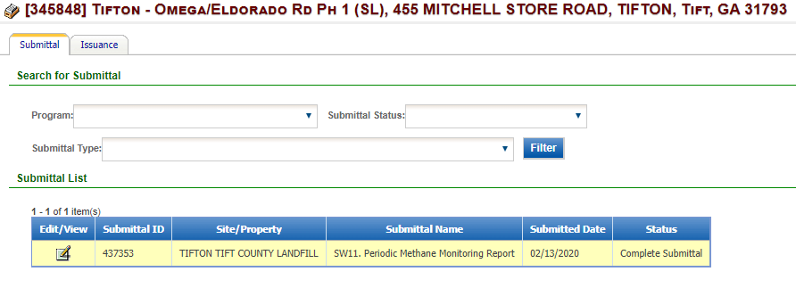

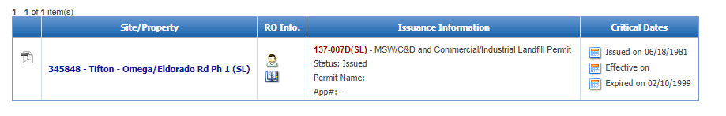

LEMIR ID: 6818 -- Tifton/Tift County Landfill

